Big Data Project – Report 1
Iceland Short-Term Wind Forecast & Extreme Wind Alerts
Mis à jour: 18/11/2025
Tengzhe ZHANG

Project Background and Objectives
Iceland is located in the North Atlantic and is well-known for its frequent strong winds and rapidly changing weather conditions. Severe wind can significantly impact airport operations, road safety, marine activities, and tourism. Having a near real-time view of short-term wind evolution and upcoming extreme wind events can therefore be highly valuable for decision-making.

The goal of this project is to build an end-to-end big data pipeline for real-time wind monitoring and alerting focused on Iceland. The system will continuously ingest high-resolution weather forecast data, compute relevant wind-related metrics, and expose them via a dashboard.

The project has two main objectives:
- Short-term wind monitoring
Continuously monitor and visualize short-term wind speed and gust forecasts for several key locations in Iceland.

- Extreme wind event detection and alerting
Detect time periods where wind speed or gusts exceed predefined thresholds and generate “extreme wind” alerts. These alerts will be derived from time-series analysis and windowed aggregations of the forecast data.

Data Streams and Data Sources
The main data source for this project is the Open-Meteo weather forecast API. Open-Meteo provides its data for free for non-commercial uses. The data is published under a Creative Commons Attribution (CC BY 4.0) license.

Main API Endpoints and Parameters
- Monitored locations: Reykjavik, Akureyri and Keflavik

- Core endpoint: https://api.open-meteo.com/v1/forecast

- Key query parameters:
Metric name | Description
latitude, longitude | geographic coordinates for the location
hourly | comma-separated list of requested hourly variables
forecast_days | number of days to forecast
past_hours | number of past hours included, useful for short historical context
timeformat=unixtime | unix timestamps, easier to handle in Spark
timezone=UTC | common time zone for all locations
wind_speed_10m | wind speed at 10 m height
wind_gusts_10m | wind gusts at 10 m height
temperature_2m | air temperature at 2 m height
precipitation | total precipitation
pressure_msl | mean sea-level pressure

Project Schema

Overview
The system will be implemented using the architecture required in the course:
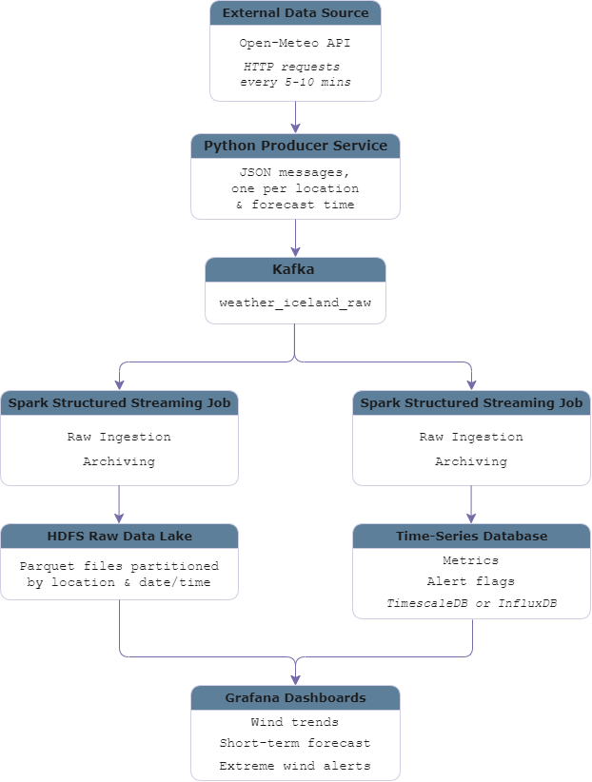

Short-Term Wind Monitoring Service
- Pipeline
For each monitored location, the system will:
- Continuously ingest hourly wind forecasts for the next 48 hours.
- Use Spark Structured Streaming to compute rolling statistics over sliding time windows:
- Average and maximum wind speed
- Maximum wind gusts
- Simple wind trend indicators
- Store these aggregated metrics in a time-series database for efficient querying and visualization.
- Provide near real-time Grafana dashboards showing wind evolution at different locations.
- Use cases
This service supports use cases like:
- Monitoring wind conditions around Reykjavík and Keflavík airport
- Comparing wind patterns between north (Akureyri) and south-west (Reykjavík/Keflavík) Iceland
- Quickly checking whether winds are strengthening or weakening over the next few hours

Service Extreme wind event detection and alerting
- Pipeline
For each monitored location, the system will:
- Reuse the same Open-Meteo forecast stream as the monitoring service, continuously ingesting hourly wind speed and gust forecasts for the next 48 hours into Kafka and then into Spark Structured Streaming
- Use Spark Structured Streaming to apply threshold checks over sliding time windows:
- Detect whether any hour in the window exceeds the extreme wind thresholds
- Count how many hours in the window are expected to experience extreme wind
- For each location and window, derive alert KPIs, such as:
- A binary flag indicating if extreme wind is expected in the upcoming window
- The expected duration of extreme wind within the window.
- Store these alert metrics in a dedicated table/measurement in the time-series database for efficient querying.
- Configure Grafana panels to:
- Highlight time ranges with extreme wind.
- Display summary views showing which locations are currently under warning and when the warnings start and end.
- Use cases
This service supports use cases like:
- Helping operators at Keflavík International Airport or coastal facilities quickly see upcoming periods with dangerous wind conditions
- Providing an overview of when and where extreme wind is expected, supporting decisions about road closures, bus schedules, and tour cancellations
- Identifying multi-hour or multi-location extreme wind episodes, allowing stakeholders to prepare in advance

Key Metrics and KPIs
This section defines the main metrics and Key Performance Indicators used in the project.

Wind and Weather Monitoring KPIs
These KPIs describe the predicted weather in the near future and are mainly displayed as time-series plots in Grafana.
Metric name | Description
wind_speed_10m_current | latest forecast wind speed at 10 m height for a given location
wind_gusts_10m_current | latest forecast wind gust at 10 m height
temperature_2m_current | latest forecast air temperature at 2 m height
precipitation_current | latest forecast hourly precipitation
pressure_msl_current | latest forecast mean sea-level pressure

Extreme Wind Alert KPIs
The second group of KPIs focuses on detecting and summarizing extreme wind situations based on predefined thresholds.
Metric name | Description
extreme_wind_flag_next_3h | binary flag indicating whether any extreme wind event is expected in the next 3 hours for a location
extreme_wind_flag_next_6h | binary flag indicating whether any extreme wind event is expected in the next 6 hours for a location
extreme_wind_duration_next_6h | number of forecast hours within the next 6 hours where wind speed or gusts exceed the threshold
extreme_wind_duration_next_12h | number of forecast hours within the next 12 hours with extreme wind conditions
extreme_wind_duration_next_12h | composite score combining maximum wind speed/gust and duration to measure how “severe” the event may be

System Health and Performance KPIs
In addition to weather-related metrics, the project also tracks KPIs that describe the health and performance of the data pipeline itself.
Metric name | Description
ingestion_rate_events_per_min | number of forecast records ingested from the API and written into Kafka per minute
kafka_consumer_lag | difference between the latest Kafka offset and the offset processed by Spark
spark_batch_processing_time | average processing time for a micro-batch in Spark Structured Streaming
end_to_end_latency | time between a record entering Kafka and the corresponding metrics being written to the DB
hdfs_raw_data_volume | total size of raw forecast data stored in HDFS over time

